COMPETITOR NAME………………………………………...... SEX MALE / FEMALE

AGE……….…… YEAR OF BIRTH…………………….. GRADE………….……

LICENCE NUMBER: M……………… EXPIRY DATE…………………………..
(No licence details = No entry!)

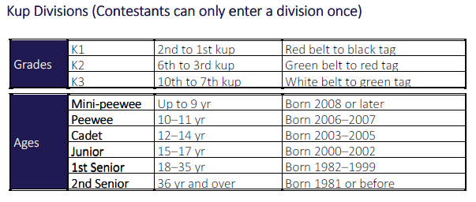
Please enclose £25 per Individual Entry.
For those wishing to take part in Pairs and Team Poomsae the club will pay that entry fee.
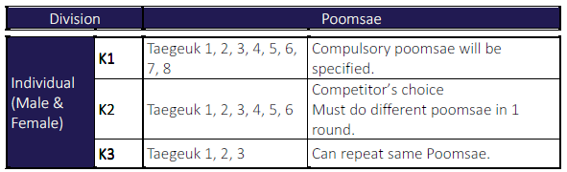
This competition is likely to fill up quickly. Therefore please complete and return by 28th November
